**DAY – 5 CLASS EXERCISES**

**CLASS EXERCISE 1**

**package** com.softwaretest1.demo1;

**import** org.openqa.selenium.By;

**import** org.openqa.selenium.WebDriver;

**import** org.openqa.selenium.WebElement;

**import** org.openqa.selenium.chrome.ChromeDriver;

**import** org.openqa.selenium.chrome.ChromeOptions;

**import** org.openqa.selenium.interactions.Actions;

**import** io.github.bonigarcia.wdm.WebDriverManager;

**public** **class** Day5_CE1 {

**public** **static** **void** main(String[] args) {

WebDriverManager.*chromedriver*().setup();

ChromeOptions co=**new** ChromeOptions();

co.addArguments("--remote-allow-origins=*");

WebDriver d=**new** ChromeDriver(co);

d.get("https://demoqa.com/droppable/");

d.manage().window().maximize();

WebElement drag=d.findElement(By.*id*("draggable"));

WebElement drop=d.findElement(By.*id*("droppable"));

Actions a=**new** Actions(d);

a.dragAndDrop(drag, drop).build().perform();

}

}

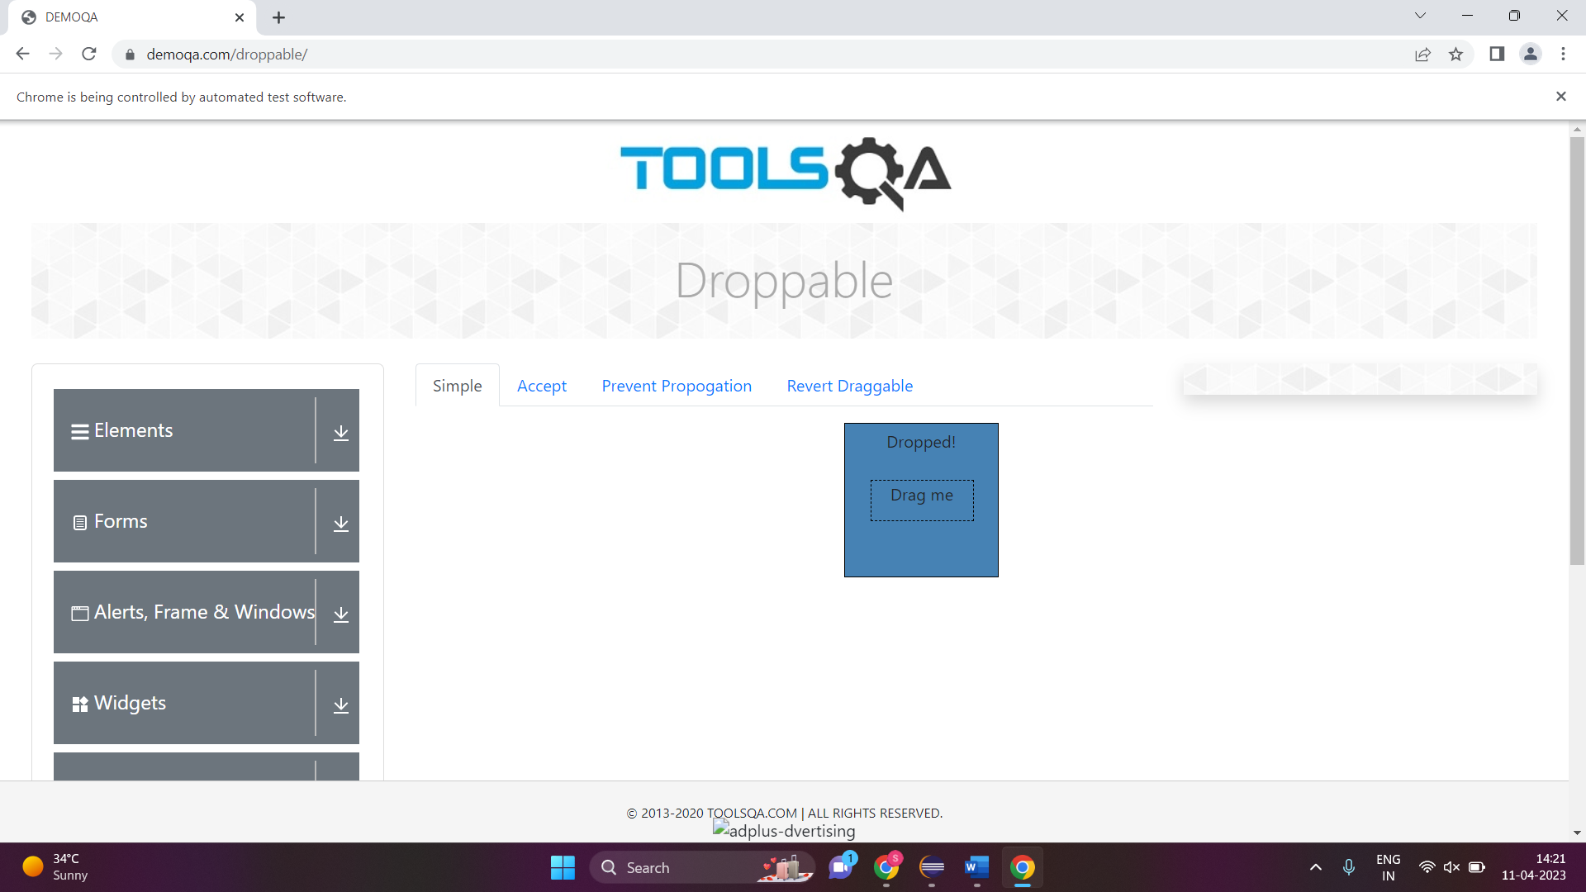

**CLASS EXERCISE 2**

**package** com.softwaretest1.demo1;

**import** org.openqa.selenium.By;

**import** org.openqa.selenium.WebDriver;

**import** org.openqa.selenium.WebElement;

**import** org.openqa.selenium.chrome.ChromeDriver;

**import** org.openqa.selenium.chrome.ChromeOptions;

**import** org.openqa.selenium.interactions.Actions;

**import** io.github.bonigarcia.wdm.WebDriverManager;

**public** **class** Day5_CE2 {

**public** **static** **void** main(String[] args) {

WebDriverManager.*chromedriver*().setup();

ChromeOptions co=**new** ChromeOptions();

co.addArguments("--remote-allow-origins=*");

WebDriver d=**new** ChromeDriver(co);

d.get("https://jqueryui.com/droppable/");

d.manage().window().maximize();

d.switchTo().frame(0);

WebElement drag=d.findElement(By.*id*("draggable"));

WebElement drop=d.findElement(By.*id*("droppable"));

Actions a=**new** Actions(d);

a.dragAndDrop(drag, drop).build().perform();

}

}

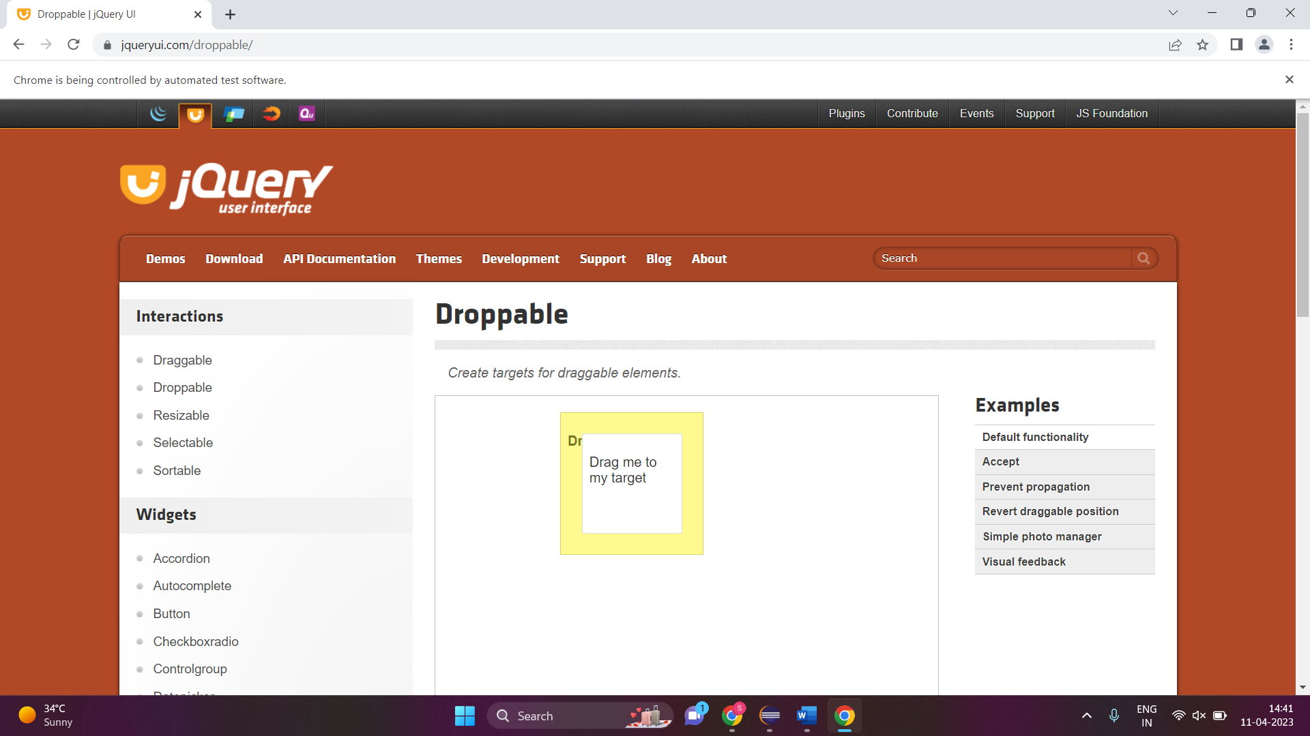

**CLASS EXERCISE 3**

**package** com.softwaretest1.demo1;

**import** org.openqa.selenium.Alert;

**import** org.openqa.selenium.By;

**import** org.openqa.selenium.WebDriver;

**import** org.openqa.selenium.WebElement;

**import** org.openqa.selenium.chrome.ChromeDriver;

**import** org.openqa.selenium.chrome.ChromeOptions;

**import** org.openqa.selenium.interactions.Actions;

**import** io.github.bonigarcia.wdm.WebDriverManager;

**public** **class** Day5_CE3 {

**public** **static** **void** main(String[] args) **throws** InterruptedException {

WebDriverManager.*chromedriver*().setup();

ChromeOptions co=**new** ChromeOptions();

co.addArguments("--remote-allow-origins=*");

WebDriver d=**new** ChromeDriver(co);

d.get("https://demo.guru99.com/test/delete_customer.php");

d.manage().window().maximize();

WebElement txtBoxl=d.findElement(By.*name*("cusid"));

txtBoxl.sendKeys("401");

WebElement submitBtn = d.findElement(By.*name*("submit"));

submitBtn.click();

Alert alertl=d.switchTo().alert();

Thread.*sleep*(3000);

alertl.dismiss();

txtBoxl.clear();

txtBoxl.sendKeys("402");

submitBtn.click();

Alert alert2=d.switchTo().alert();

alert2.accept();

Alert alert3=d.switchTo().alert();

String txt=alert3.getText();

alert3.accept();

System.***out***.println(txt);

}

}

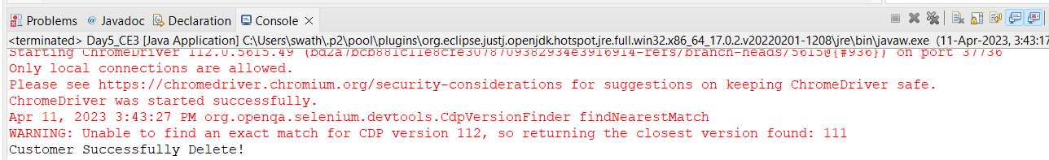

**CLASS EXERCISE 4**

**package** com.softwaretest1.demo1;

**import** org.openqa.selenium.Alert;

**import** org.openqa.selenium.By;

**import** org.openqa.selenium.WebDriver;

**import** org.openqa.selenium.WebElement;

**import** org.openqa.selenium.chrome.ChromeDriver;

**import** org.openqa.selenium.chrome.ChromeOptions;

**import** io.github.bonigarcia.wdm.WebDriverManager;

**public** **class** Day5_CE4 {

**public** **static** **void** main(String[] args) **throws** InterruptedException {

WebDriverManager.*chromedriver*().setup();

ChromeOptions co=**new** ChromeOptions();

co.addArguments("--remote-allow-origins=*");

WebDriver d=**new** ChromeDriver(co);

d.get("https://www.abhibus.com/bus-ticket-booking");

d.manage().window().maximize();

d.findElement(By.*name*("journey_date")).click();

d.findElement(By.*xpath*("//*[@id=\"ui-datepicker-div\"]/div[1]/table/tbody/tr[3]/tr[5]/a")).click();

}

}

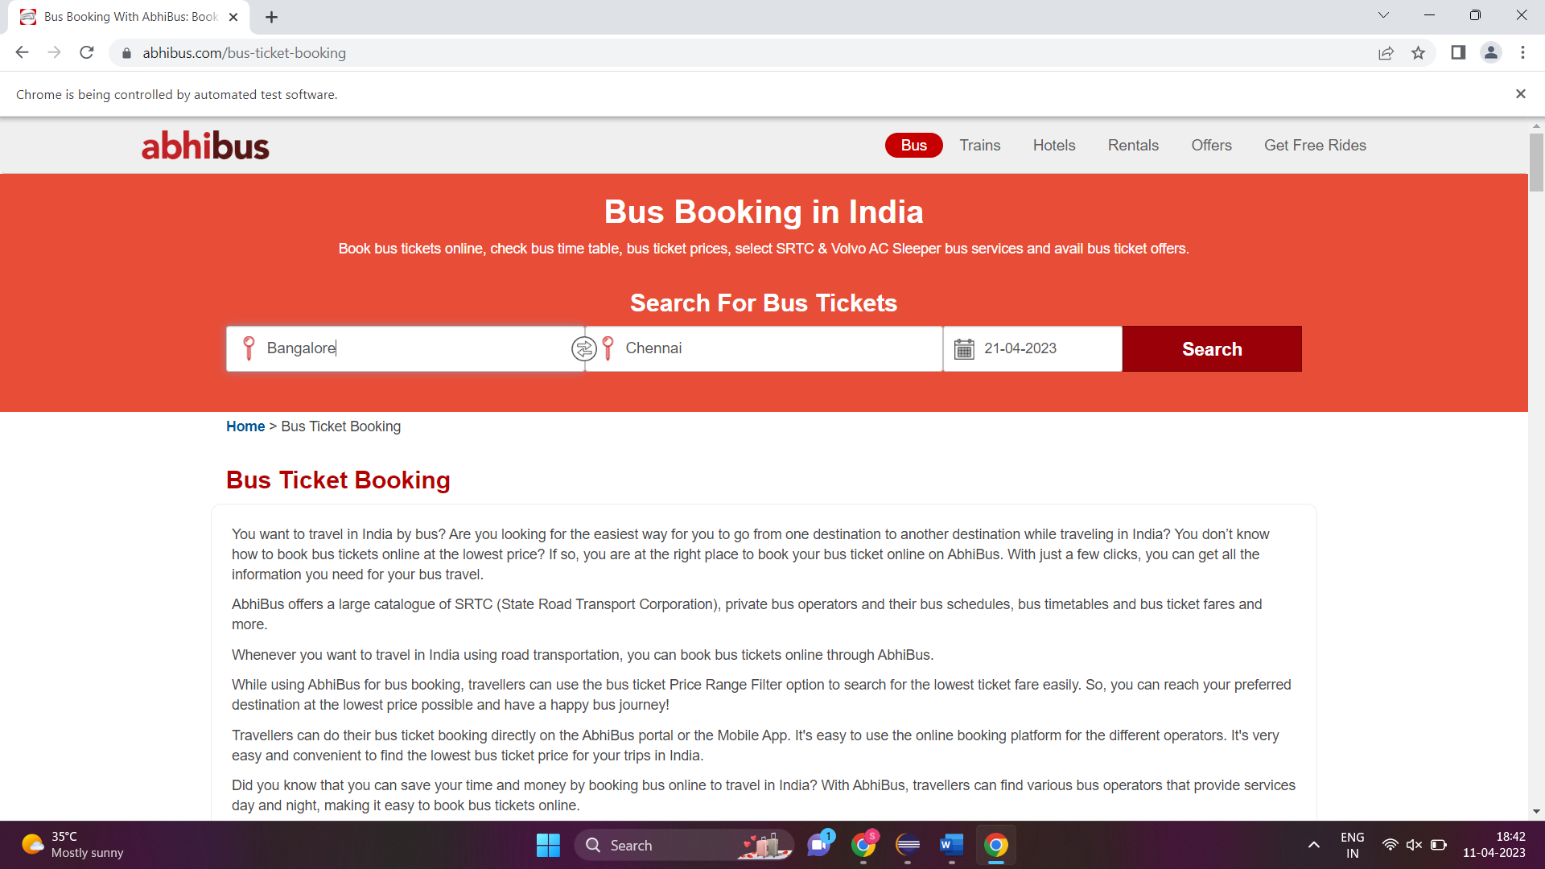

**CLASS EXERCISE 5**

**package** com.softwaretest1.demo1;

**import** org.openqa.selenium.Alert;

**import** org.openqa.selenium.By;

**import** org.openqa.selenium.Keys;

**import** org.openqa.selenium.WebDriver;

**import** org.openqa.selenium.WebElement;

**import** org.openqa.selenium.WindowType;

**import** org.openqa.selenium.chrome.ChromeDriver;

**import** org.openqa.selenium.chrome.ChromeOptions;

**import** io.github.bonigarcia.wdm.WebDriverManager;

**public** **class** Day5_CE5 {

**public** **static** **void** main(String[] args) **throws** InterruptedException {

WebDriverManager.*chromedriver*().setup();

ChromeOptions co=**new** ChromeOptions();

co.addArguments("--remote-allow-origins=*");

WebDriver driver=**new** ChromeDriver(co);

driver.get("https://www.google.com");

driver.manage().window().maximize();

driver.findElement(By.*name*("q")).sendKeys("Apple");

driver.findElement(By.*name*("q")).sendKeys(Keys.***ENTER***);

System.***out***.println(driver.getWindowHandle());

System.***out***.println(driver.getTitle());

driver.switchTo().newWindow(WindowType.***TAB***);

driver.get("https://www.google.com");

driver.manage().window().maximize() ;

driver.findElement(By.*name*("q")).sendKeys("selenium");

driver.findElement(By.*name*("q")).sendKeys(Keys.***ENTER***);

System.***out***.println("\n"+driver.getWindowHandle());

System.***out***.println("\n"+driver.getTitle());

driver.switchTo().newWindow(WindowType.***TAB***);

driver.get("https://www.google.com");

driver.manage().window().maximize() ;

driver.findElement(By.*name*("q")).sendKeys("dell");

driver.findElement(By.*name*("q")).sendKeys(Keys.***ENTER***);

System.***out***.println("\n"+driver.getWindowHandle());

System.***out***.println("\n"+driver.getTitle());

}

}

